BOOK REPORT #3 - GRAPHIC NOVEL - Script It!  Select a Graphic Novel from the list of books that appear in the right hand column. Step 1 - Write a Movie Script for your favorite scene from the novel. Step 2 - Assign real-life TV or movie stars to play each of the characters. Step 3 - Storyboard the scene that you selected. See sample excerpts below for details. (Please note that the example below is short in length. Your Script and Storyboard must be a minimum of three pages. Your storyboard  must be illustrated. DO NOT just photocopy the graphic novel.  EXT. RIVER BANK - CONTINUOUS - NIGHT  Eric notices something odd in the river.  ERIC  What's that?  The others look down in the murky water. Just below the surface,  A SHIMMERING WAVE OF SILVER passes beneath the boat.  ERIC  Something must've scared them.  WHAM!  The SUV is RAMMED, sending everyone tumbling.  SUPERCROC (Suchomimus)  rises from the water, towering over the Sports-Utility-Vehicle. As lightning FLASHES and thunder CRACKS, the prehistoric monster lets out an ear-splitting ROAR. (Continued on next page)  Story Characters Movie Star (Actor/Actress)  Eric Cooper - Hugh Jackman  Amanda Kirby - Lindsay Lohan  Billy Brennan - Will Smith  The Lost World Story & Screenplay by Michael Crichton  Sample Movie Script:  Favorite Scene from the Novel “The Lost World.”  SAMPLE STORYBOARD  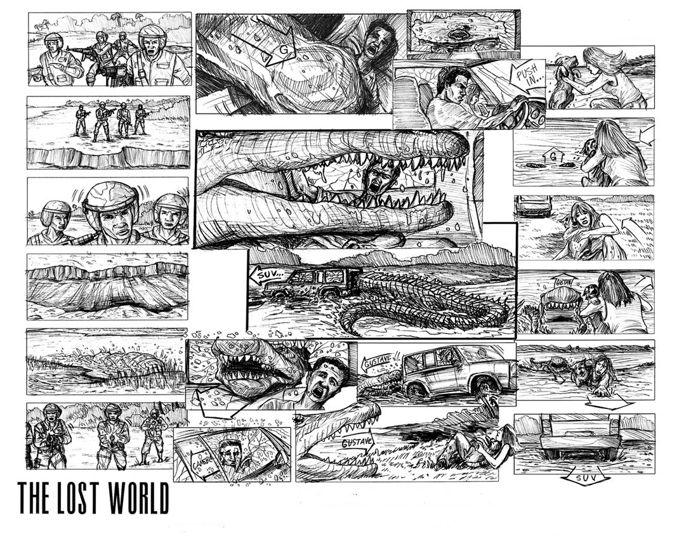 | GRAPHIC NOVEL TITLES DUE DATE:_________  Adam: Legend of the Blue Marvel by Robert Murray  Age of Bronze Volume 1: A Thousand Ships by Eric Shanower  Alias Vol. 1 by Brian Michael Bendis  American Born Chinese by Gene Luen Yang  Animal Man, "Deus Ex Machina"by Grant Morrison  Astro City: Life in the Big City by Kurt Busiek  Atomic Robo, Volume 1: by Brian Clevinger  Batman: Hush vol 1 & 2 Written by Jeph Loeb  Batman - "The Long Halloween" Written by Jeph Loeb  Batman: Dark Victory Written by Jeph Loeb  Batman: Year One by David Mazzucchelli  Batman: The Dark Knight Returns by Frank Miller  Batman And Robin Vol 01 Or 02 by Grant Morrison  Batwoman: Elegy by Greg Rucka  Beowulf by Gareth Hinds  Bone by Jeff Smith  Cairo by G. Willow Wilson  Captain America, Omnibus by Ed Brubaker  Catwoman: When in Rome by Jeph Loeb  Criminal (Vol. 1): Coward by Ed Brubaker  Crisis on Infinite Earths by Marv Wolfman and George Perez  Dark Tower: Gunslinger Born by Peter David  Dark Tower: The Long Road Home by Peter David  Daredevil Omnibus, Vol. 1 by Ed Brubaker  Daredevil Omnibus Vol. 2 by Brian Michael Bendis & Alex Maleev  DC: The New Frontier, Vol. 1 & 2 by Darwyn Cooke  DMZ Vol. 1: On the Ground by Brian Wood  Ex Machina, Vol. 1: The First Hundred Days by Brian K. Vaughan  Exit Wouds Written by Rutu Modan  Fables: 1001 Nights of Snowfall by Bill Willingham  Fantastic Four: Books of Doom by Ed Brubaker  Ghost World by Daniel Clowes  Green Arrow: Year One by Andy Diggle  Green Lantern: The Sinestro Corps War, Vol. 1 & 2 by Geoff Johns  Green Lantern: Rebirth Vol. 1 by Geoff Johns  Hobbit, The by Charles Dixon (Adapter), J.R.R. Tolkien  Identity Crisis by Brad Meltzer  Incognito by Ed Brubaker  Incredible Hulk, The : Planet Hulk by Greg Pak  Invincible: The Ultimate Collection, Vol. 1 by Robert Kirkman  Iron Man: Demon in a Bottle by David Michelinie  Kill Shakespeare Vol 01 By Conor Mccreery  Kingdom Come by Mark Waid  Mouse Guard Volume 1: Fall 1152 by David Petersen  Northlanders Vol. 1: Sven The Returned by Brian Wood  Persepolis," by Marjane Satrapi  Powers Vol. 1: Who Killed Retro Girl? (Vol 1) by Brian Michael Bendis  Pride of Baghdad by Brian K. Vaughan  Sandman: Season of Mists by Neil Gaiman  Secret History, The Volume 1 by Jean-Pierre Pecau  Sleeper: Season One by Ed Brubaker  Spider-Man, Amazing : Ultimate Collection 1 by J. Michael Straczynsk  Star Wars: Dark Empire Trilogy by Tom Veitch  Star Wars: The Thrawn Trilogy by Timothy Zahn & Mike Baron  Superman, All Star Vol. 1 by Grant Morrison  Superman: Red Son (Elseworlds) by Mark Millar  Superman, Earth One by J. Michael Straczynsk  Thor by Michael Straczynski Omnibus  Top Ten: The Forty-Niners by Alan Moore  Umbrella Academy Vol.1: Apocalypse Suite by Gerard Way  Usagi Yojimbo, Book 1: The Ronin by Stan Sakai  V for Vendetta by Alan Moore  Wolverine: Old Man Logan by Mark Millar  Wolverine Origin (Vol. 1) by Paul Jenkins  Wolverine: Weapon X by Barry Windsor-Smith  X-Men, Astonishing Omnibus by Joss Whedon  X-Men: X-23, Astonishing - Innocence Lost by Craig Kyle  X-Men: Magneto Testament by Greg Pak  X-Men, New "E is For Extinction" by Grant Morrison  Y: The Last Man, Vol. 1: Unmanned by Brian K. Vaughan.  * If you would like to read a Graphic Novel that doesn’t appear on the  list, please see your teacher for permission to use an alternative title.

